

Practices for Secure Software Report

Table of Contents
Document Revision History 3
Client 3
Instructions 3
Developer 4
1. Algorithm Cipher 4
2. Certificate Generation 4
3. Deploy Cipher 4
4. Secure Communications 4
5. Secondary Testing 4
6. Functional Testing 4
7. Summary 4
8. Industry Standard Best Practices 4

Document Revision History

Version | Date | Author | Comments
1.0 | 10/14/2026 | Eric Long | Initial Project Two submission

Client



Developer
Eric Long

Algorithm Cipher
For this project, I selected SHA-256 as the cryptographic hash algorithm used to generate the checksum. SHA-256 is part of the SHA-2 family and is commonly used to verify data integrity. A checksum allows users to confirm that information has not been altered during transmission.
SHA-256 generates a 256-bit hash value from an input string. Unlike encryption, hashing is a one-way process, and the original data cannot be recreated from the hash value. If even a small change is made to the original data, the resulting checksum changes completely.
Older algorithms such as MD5 and SHA-1 were widely used in the past, but they are now considered less secure because successful collision attacks have been demonstrated against them. SHA-256 remains an accepted industry standard because it provides stronger collision resistance and better protection against unauthorized modification of data. The algorithm is useful for checksum verification because it helps verify data integrity when information is transferred between systems.

Certificate Generation
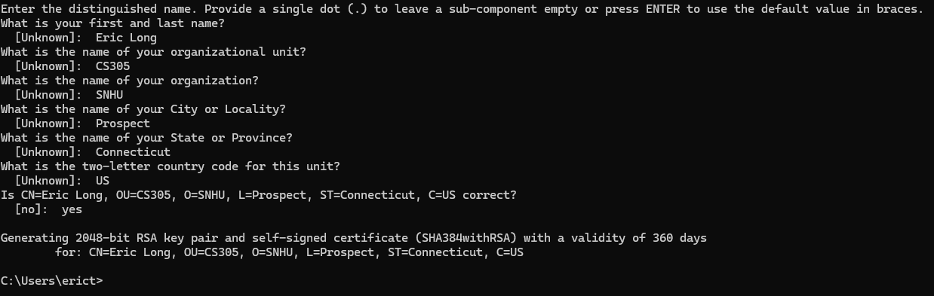

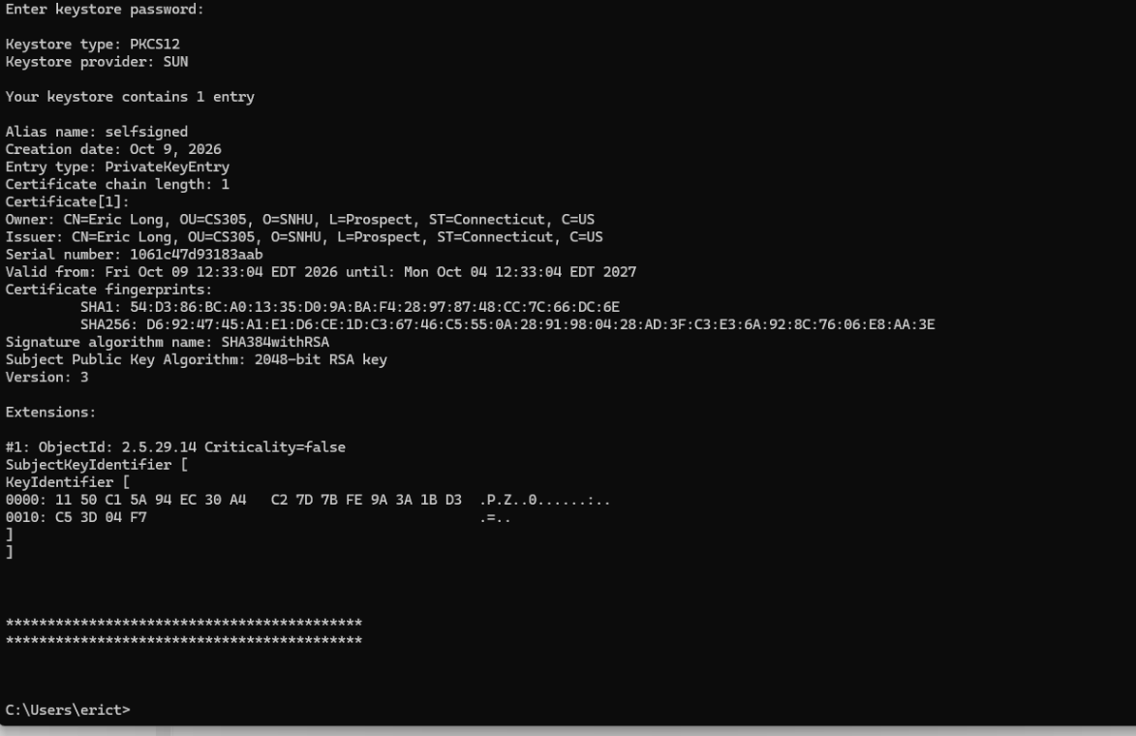

Deploy Cipher
The application was refactored to generate a SHA-256 checksum from a unique data string containing my name. Java's MessageDigest class was used to generate the checksum value, and the resulting hash is returned through a REST endpoint.
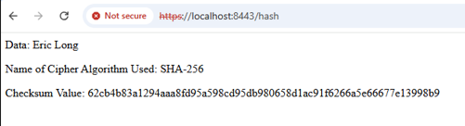

Secure Communications
HTTPS was implemented through the use of a self-signed certificate generated with Java Keytool. The application was configured to use TLS encryption through the application properties file and listen on port 8443 for secure communications. The browser displays a warning because a self-signed certificate was used rather than a certificate issued by a trusted Certificate Authority.

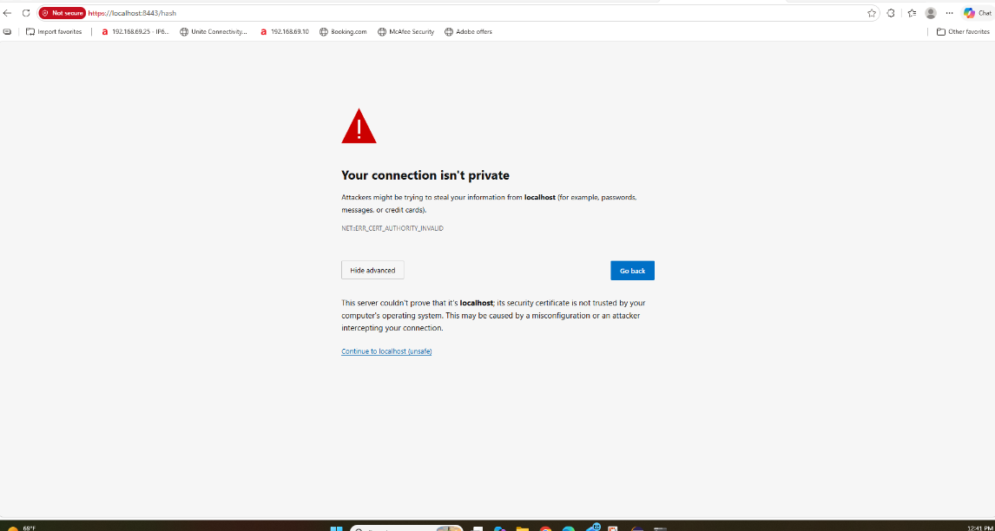

Secondary Testing
OWASP Dependency-Check was executed after the application was refactored to verify that no additional vulnerabilities were introduced into the application. The static analysis process reviewed project dependencies and identified known vulnerabilities associated with third-party libraries.
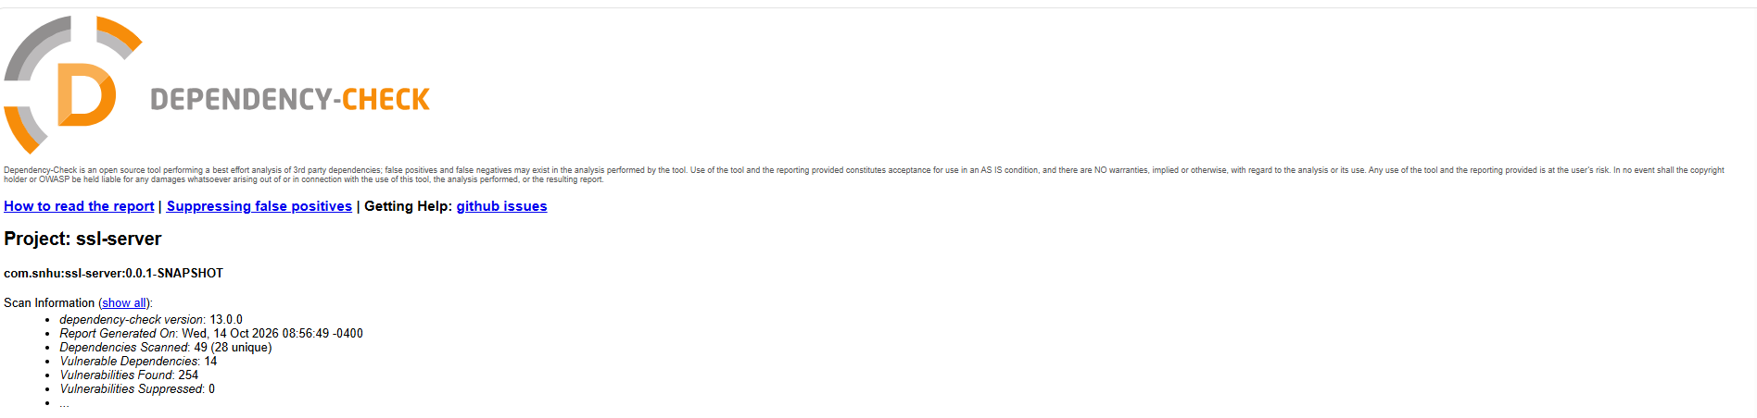

Functional Testing
Functional testing was completed after the application was configured and refactored. The application compiled and executed successfully without runtime errors. Testing confirmed that the HTTPS endpoint was accessible and that checksum generation functioned correctly.
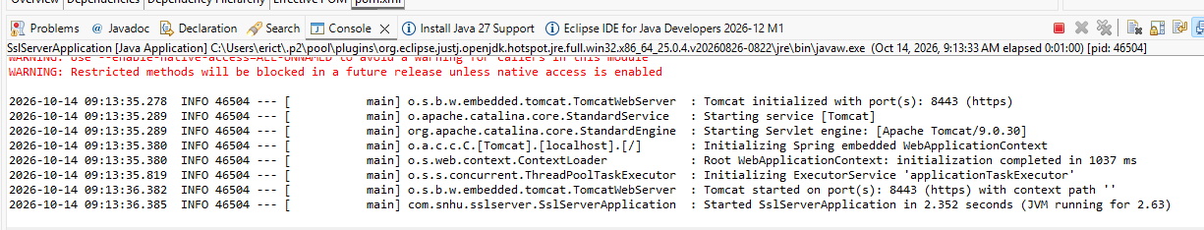
During functional testing, the application was manually reviewed for syntax, logic, and security issues. The refactored application executed successfully without runtime errors, and HTTPS communication and checksum verification operated as expected.

Summary
The Artemis Financial application was refactored to improve software security by implementing HTTPS communication, certificate-based encryption, SHA-256 checksum verification, and dependency-check security testing. Several security areas identified within the vulnerability assessment process were addressed, including cryptography, client/server communications, APIs, code quality, and secure coding practices.
Multiple layers of security were added throughout the application. A self-signed certificate was generated and configured using Java Keytool to support encrypted HTTPS communications. A SHA-256 checksum was implemented to verify data integrity during transmission. OWASP Dependency-Check was also used to review software dependencies and identify known vulnerabilities.
These improvements increase application security while supporting secure software development practices and helping to protect customer information.
The project addressed several areas of security from the vulnerability assessment process, including cryptography, APIs, client/server communications, code quality, and secure coding practices.

Industry Standard Best Practices
Several industry standard best practices were applied throughout this project. HTTPS was used to encrypt communications between the client and server, helping to protect sensitive information during transmission. SHA-256 was selected because it provides stronger collision resistance than older hashing algorithms such as MD5 and SHA-1. Dependency-Check was used to identify known vulnerabilities in third-party libraries and assist with vulnerability management.
Secure coding practices help reduce risk, improve software reliability, and protect organizational and customer data. Following industry standard best practices enables organizations to strengthen their security posture, maintain customer trust, and support long-term software security.

References
Oracle. (n.d.). MessageDigest (Java Platform SE 8). https://docs.oracle.com/javase/8/docs/api/java/security/MessageDigest.html

Oracle. (n.d.). The keytool command. https://docs.oracle.com/en/java/javase/25/docs/specs/man/keytool.html

OWASP Foundation. (n.d.). OWASP Dependency-Check. https://owasp.org/www-project-dependency-check/

